INTRODUCTION

One day in 1848, the first President of the Royal Society of Chemistry, R.W. Hofman was saying “…in an ideal chemical factory there is, strictly speaking, no waste but only products. The better a real factory makes use of its waste, the closer it gets to its ideal, the bigger is the profit” (Lancaster 2002)”. This is what I want to present to you today. Not only a way for becoming a friendlier company, but also making profit of it by attracting more customers, expanding our selling and reducing operation costs. As the senior leadership team of one of the most respected design and manufacturing car companies in the world, it is both your responsibility and in your interest to assure that we are moving towards the right global economy direction.

UK people throw away more than 26.000 tonnes of materials and products annually, with less than half recycled. On top of this, add the 48.000 tons thrown by the companies, by which only 21% ends up recycled (Smedley, 2014). Our firm helps to increase these numbers in an immoral manner that is helping neither ourselves, nor the planet.

In today’s presentation I will focus on giving an outline of how our company can become a leader in our sector by embedding the circular economy principle. I will begin by defining what this involves, continuing by exemplifying successful implementations of this and the challenges they have encountered in the process. The last part will emphasis a developed model specifically for our product.

CIRCULAR ECONOMY – BROAD UNDERSTANDING

Circular economy refers to the principle of keeping resources in use as long as possible, by extracting the maximum value through processes of recycling (“Wrap and The Circular Economy | WRAP UK”). It is in the same time an innovative alternative to the traditional economy based on the three causal factors of making – usage – disposal. The picture below gives a more understandable representation of this principle. Unlike now, a company should be responsible for its products until the day they disappear from earth, not the day they are sold.

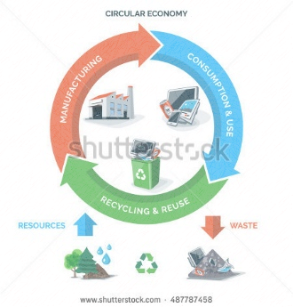

The European Commission associates circular economy to production strategies such as “boosting recycling and preventing loss of valuable materials; creating jobs and economic growth; reducing greenhouse emissions and environmental impacts” (Bocken et al., 2016). Moreover, the European Environment Agency talks about a minimization in terms of imports from Europe into the UK and a movement towards a more autochthone market.

In this way, an airline company will have to take care of what happens to the plane even after it is no longer reliable for flights, or a car manufacturer, such as us, is responsible for what happens to their sold products after the client disposes it. In order for this to be fulfilled, the producers need to come with new and attractive offers for their clients to make them understand the importance of recycling for both the planet, and themselves through discounts or promotions. This is a form of transactional leadership, form based on the exchange between followers and leaders. It assumes that followers are motivated by some kind of repayment by the leaders that provide it in exchange for a service, for example, in our case bringing the used tires back or using our service systems so we can further recycle the materials changed (Northouse, 2013:185).

WHY SHALL WE IMPLEMENT CIRCULAR ECONOMY

. For us, it will mean a development on the services and maintenance workshops leading to a higher profit number and to creating more work positions. People have the tendency to repair their cars and change the tires at a local car service due to the lower costs, not thinking at the quality of the materials for the longer-run. This phenomenon brings us with little profit on service and the necessity to bring a faulty contribution to the global unemployment number.

SUCCESSFUL EXAMPLES

Airline companies are leading the numbers in pollution statistics and are also the ones to come with the hardest solutions for such problems. However, Alaska Airlines managed to lower their negative impact upon environment by bringing an innovative idea of leather seats reprocess into “handbags and purses” ("How Big Brands, Small Startups Have Partnered To Push The Circular Economy | Sustainable Brands").

All this was possible through a partnership with Southwest Airlines, where the social enterprise “collects, sorts and cleans the seat materials”, before designing, producing and selling new models. To the moment we speak, they managed to save more than 10 million gallons of water by repurposing 5.000 pounds of leather seats. Greg Mays, the vice president of Alaska’s airline says about all this that “by partnering with these innovative designers, we’re not only diverting waste from local landfills, but we’re giving people a chance to own a piece of Alaska’s history. It’s not often that people can own a bag that has already traveled more miles than they have” (Cosgrove, 2014). Here is a visual representation of some of the models they managed to create so far:

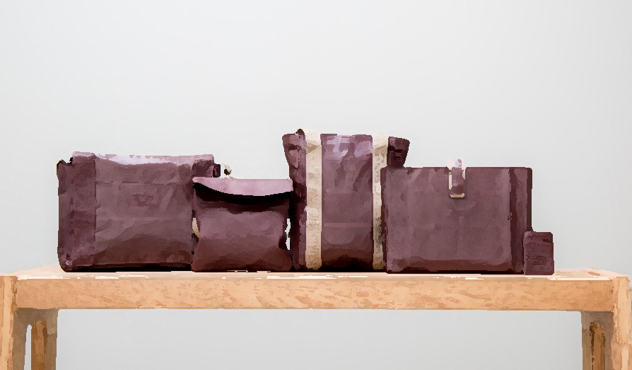

Another considerate partnership that is moving towards circular economy is between Timberland and Omni United. They are changing used tires into footwear outsoles by introducing a new model of material. The two companies have established a return policy that ensures the tires will go to the recycling facilities in their way to a new life as part of a Timberland product ("Timberland, Omni United Launch First Tire-To-Shoe Lifecycle Brand | Sustainable Brands"). In 2014 Timberland announced a 50% reduction in greenhouse gas emissions (GHGs) since 2006.

UK – WHERE DOES IT STAND AND THE CHINESE EXAMPLE

In terms of circular economy development at a national level the ideas and practices, as well as the future of it is still uncertain. It will most certainly at a point have to adapt to the global changes and follow the direction of travel to a sustainable economy.

As a firm that exports products at a global level, the international context is as important as the local one. The European Commission adapted in 2017 “circular economy principles into its 11th Five-Year Plan, 10 years apart from China (Mathews and Tan, 2016). China is leading in power of example of waste managing when they reached a resources critical level. They found a solution that worked on improving numbers as 46% aluminum, 50% steel and 60% cement of the world’s total production, leading to a usage of raw material of 25.2 billion tonnes per year.

HOW CAN IT WORK FOR US – CHALLENGES VS ADVANTAGES

The Carbon Trust recent report its bringing to the public attention findings acknowledging that remanufacturing uses with 85% less energy than the first manufacturing. This translated at a global level, it means a lowering with 800.000 tonnes of CO2 emissions per year (Goodwin, 2015). Jaguar Land Rover is one of the influential brands that understood this profit and is nowadays using over 50% recycled aluminum on their latest models. It does not only bring a shortage in costs to the company, as this is one of the expensive materials used for the manufacture of a car, but it is also saving half of the amount they were previously using from the Earth resources (Goodwin, 2015).

It might look like a concept that involves an element of high risk, as any investment and change, but as Goodwin (2015) is mentioning, “business as usual is not always the safest path”. In a competitive UK economy, the short-term profits will give lower result than a long term thinking. Businesses that understand the need to adapt to change and to the nature conditions, will face a less risk in the future. The finite resources we are using are being depleted (WWF 2010, 2012) and that we are using more than we can ever replace (D. Meadows et al. 2004; D.H. Meadows et al. 1992). IPCC since 2007 and Stott et al. in 2010 are raising the problem of climate situation worsening and that this is not likely to improve in the foreseen upcoming (UNEP, 2012).

The Circular Economy is a still developing concept that did not gain much attention to the research field and so there are still uncertainties of how this will help leading to a more equal society. We are globally facing intra- and inter-generational equity, gender, racial or religious gaps (Murray et al. 2017). Jill Rubery is bringing the problem of gender pay gap by demonstrating that “empirical studies in many EU member states demonstrate that the work environment—the general wage structure, job and workplace characteristics—shapes gender pay inequality”. These are example that the new economy is not bringing any improvement.

Circular Economy approach has also brought critiques in terms of over-simplified goals and having unintended harmful consequences to the environment. For example, “the green fuel driver has led to large areas in Borneo being cleared of forest in order to plant oil palms”, leading to the desolation of habitat for orangutans and cloud leopards (Fitzherbert et al. 2008). This has to be clearly considered before making a final plan of recycle and remanufacturing to our products.

CONCLUSION

The Circular Economy has proven to be the future in terms of economy and will end to the extension of the traditional form of business. As our planet resources are finite we always have to find new ways in order to assure a future for the next generations and for the future of our business. Recycling, remanufacturing, and sharing are the three best ways nowadays that can help preserve our resources for the longer term. Successful examples on both private, such as Alaska Airlines and Timberland, and or national level, such as China, are the living proof that this type of economy can be successful. This new way of economy will not only create new opportunities for self-growth, but will reduce waste and drive higher resource productivity, leading in the end to a more competitive UK economy.

Bibliography:

1. Smedley, Tim. "The Circular Economy Debate: Examples Of Good Practice In Business". *the Guardian*. N.p., 2017. Web. 21 Apr. 2017.
2. "WRAP And The Circular Economy | WRAP UK". *Wrap.org.uk*. N.p., 2017. Web. 22 Apr. 2017.
3. "How Big Brands, Small Startups Have Partnered To Push The Circular Economy | Sustainable Brands". *sustainablebrands.com*. N.p., 2017. Web. 24 Apr. 2017.
4. Cole Cosgrove, Staff Writer. "Reborn As Carry-On Bags, Recycled Airplane Seat Leather Will Continue To Fly". *Alaska Airlines Blog*. N.p., 2017. Web. 24 Apr. 2017.
5. Lancaster, M. (2002). Principles of sustainable and green chemistry. In J. Clark, & D. Macquarrie (Eds.), Handbook of Green Chemistry and Technology (pp. 10-27). Oxford: Blackwell.
6. Murray, A., Skene, K. & Haynes, K. The Circular Economy: An Interdisciplinary Exploration of the Concept and Application in a Global Context, *Journal of Business Ethics* (2017) 140: 369. Available from: [10.1007/s10551-015-2693-2](file:///\\ds.man.ac.uk\csistgdrive\sdce\Manchester%20Leadership%20Programme\2016-17\Assessment\Online_SEM%202\Summative%20Development\10.1007\s10551-015-2693-2)
7. "Timberland, Omni United Launch First Tire-To-Shoe Lifecycle Brand | Sustainable Brands". *sustainablebrands.com*. N.p., 2017. Web. 24 Apr. 2017.
8. Bocken, N. M. P., de Pauw, I., Bakker C. & van der Grinten B. (2016) Product design and business model strategies for a circular economy*, Journal of Industrial and Production Engineering*, 33:5, 308-320, Available from: [10.1080/21681015.2016.1172124](file:///\\ds.man.ac.uk\csistgdrive\sdce\Manchester%20Leadership%20Programme\2016-17\Assessment\Online_SEM%202\Summative%20Development\10.1080\21681015.2016.1172124)
9. "Circular Economy To Have Considerable Benefits, But Challenges Remain — European Environment Agency". *Eea.europa.eu*. N.p., 2017. Web. 26 Apr. 2017. Available at: <http://www.eea.europa.eu/highlights/circular-economy-to-have-considerable>
10. Goodwin, L. (2015) How to bust the biggest myths about the circular economy. [online] The Guardian, Thursday 12th March 2015. Available From: <https://www.theguardian.com/sustainable-business/2015/mar/12/circular-economy-myths-busted-reality-check>
11. UNEP (2012). GEO5 Global Environmental Outlook: Environment for the future we want. United Nations Environment Programme
12. WWF (2010). Living Planet Report 2010: Biodiversity, Biocapacity and Development. WWF International.
13. WWF (2012). Living Planet Report 2012: Biodiversity, biocapacity and better choices. Gland, Switzerland: WWF International.
14. Stott, P. A., Gillett, N. P., Hegerl, G. C., Karoly, D. J., Stone, D. A., Zhang, X., et al. (2010). Detection and attribution of climate change: a regional perspective. Wiley Interdisciplinary Reviews: Climate Change, 1(1), 1-20.
15. IPCC (2007). Fourth Assessment Report. Geneva: WMO/Intergovernmental Panel on Climate Change.
16. Meadows, D., Randers, J., & Meadows, D. (2004). Limits to Growth: The 30-Year Update. London: Earthscan.
17. Meadows, D. H., Meadows, D. L., & Randers, J. (1992). Beyond the Limits. Post Mills, VT: Chelsea Green Publishing.
18. Murray, A., Skene, K. & Haynes, K. The Circular Economy: An Interdisciplinary Exploration of the Concept and Application in a Global Context, *Journal of Business Ethics* (2017) 140: 369. Available from: [10.1007/s10551-015-2693-2](file:///\\ds.man.ac.uk\csistgdrive\sdce\Manchester%20Leadership%20Programme\2016-17\Assessment\Online_SEM%202\Summative%20Development\10.1007\s10551-015-2693-2)
19. Northouse, Peter Guy. *Leadership*. 1st ed. Los Angeles [u.a.]: SAGE, 2013. Print.
20. Mathews, J, & Tan, H. (2016) Circular Economy, Lessons from China. Nature, Volume 531, 24 March 2016, pp 440-442, Available from: <http://www.nature.com/news/circular-economy-lessons-from-china-1.19593>
21. Rubery, Jill, and Collette Fagan. *Occupational Segregation Of Women And Men In The European Community*. 1st ed. Luxembourg: Office for Official Publications of the European Communities, 1993. Print.
22. Murray, A., Skene, K. & Haynes, K. The Circular Economy: An Interdisciplinary Exploration of the Concept and Application in a Global Context, *Journal of Business Ethics* (2017) 140: 369. Available from: [10.1007/s10551-015-2693-2](file:///\\ds.man.ac.uk\csistgdrive\sdce\Manchester%20Leadership%20Programme\2016-17\Assessment\Online_SEM%202\Summative%20Development\10.1007\s10551-015-2693-2)
23. Fitzherbert, E. B., Struebig, M. J., Morel, A., Danielsen, F., Brühl, C. A., Donald, P. F., et al. (2008). How will oil palm expansion affect biodiversity? . Trends in Ecology and Evolution, 23, 538-545.